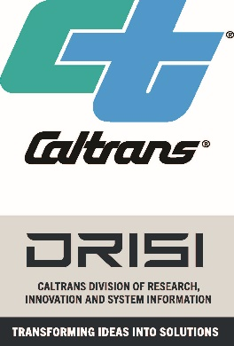 | The National Center for Sustainable Transportation  University Transportation Center  Fact Sheet

The National Center for Sustainable Transportation (NCST) was selected as the United States Department of Transportation (US DOT) National University Transportation Center (UTC) under the Infrastructure Investment and Jobs Act (IIJA). NCST was awarded a five-year grant totaling approximately $20 million from the US DOT, and the only national center focused on the IIJA research priority area of Preserving the Environment. This center is located at the Institute of Transportation Studies at the University of California, Davis.

NCST provides national leadership in advancing environmentally sustainable transportation through cutting-edge research, direct policy engagement, and education of our future leaders. The Institute of Transportation Studies at the University of California, Davis (ITS-Davis) leads the NCST in partnership with California State University, Long Beach; Georgia Institute of Technology; Texas Southern University; the University of California, Riverside; the University of Southern California; and the University of Vermont.

The NCST’s research program is working toward equitable decarbonization of the transportation sector through high-priority projects that inform policy in the public and private sectors and that address the needs of diverse communities. The NCST addresses the challenge of accelerating reductions in greenhouse gas emissions while enhancing transportation equity with work that contributes to the fundamental policy transformation essential to accelerating decarbonization in a way that ensures that the benefits of the transportation system are broadly distributed and that the well-being of people in overburdened and historically disadvantaged communities is substantially improved. To address these challenges, the NCST’s research, education, and engagement programs are organized around the following high-priority themes:
- Infrastructure Provision
- Travel Demand
- Vehicle Technology

The NCST receives funding from the U.S. DOT, the California Department of Transportation, the California Air Resources Board, the California Energy Commission, the South Coast Air Quality Management District, and sources in the States of Georgia, Texas, and Vermont.

Current Five-Year Contract Term: ~ April 1, 2024 – June 30, 2029

